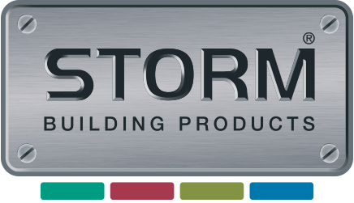

To view all products available to order via our Partner Storm Building Products, please follow this link:

<https://stormbuildingproducts.com/catalogue-request/>